Summer Reading Challenge 2015!
Larson Middle School
You could win a Kindle or other great prizes
while you enjoy reading this summer!!

Here’s how:

- Read at least 1,000 minutes (That’s only 20 minutes a day, five days a week for the summer.) These websites will help you find great books to read:
  - http://www.summerreadingnys.org/teens/teens-booklists/
  - http://www.goodreads.com/list/show/1606.Top_100_Middle_School_Must_Reads
  - http://www.ala.org/alsc/2014-summer-reading-list
(Note: These websites are intended to be guidelines only. Use your own care and consideration when choosing great books to read.)

- Keep checking the Larson Summer Schoology page for book reviews and recommendations from students and teachers!

- Fill out the Reading Log (on the back of this flier and available on the Larson Summer Schoology website all summer long) and have your parents sign it.

- Bring it back to school in the fall for your prizes!

PRIZES:
GRAND PRIZE: Your name goes in the drawing for a Kindle if you read a minimum of 1,000 minutes! You get an extra ticket in the drawing for each 500 minutes over 1,000

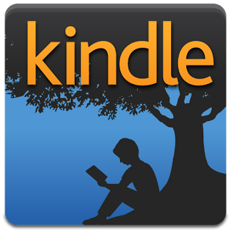
Other prizes include gift cards and more! Enjoy a book-filled summer!

READING LOG
SUMMER 2015 Name: _______________________

DATE | BOOK TITLE | MINUTES READ ON  THIS DATE | TOTAL MINUTES READ  (cumulative total)

Parent Signature: ________________________________________________
(Additional pages may be copied or printed off from the Larson Summer Schoology website.)

